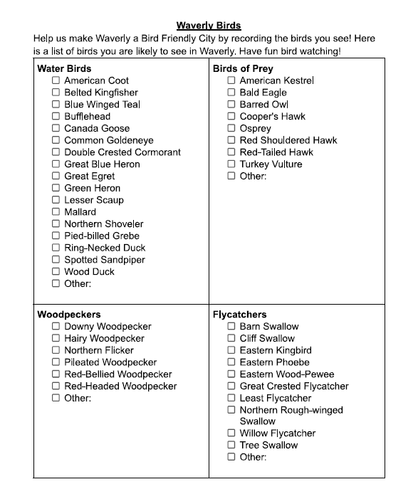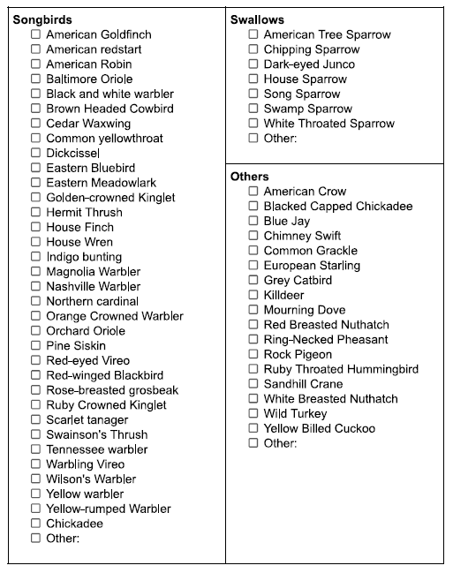

Once completed, please take a picture and email to one of the following emails:
aborglum26@wrs.k12.ia.us, acorocran26@wsr.k12.ia.us, eschneiderman26@wsr.k12.ia.us

